Ultrastructural evidence of a mechanosensory function of scale ‘sensilla’ in sea snakes (Hydrophiinae)
Jenna M. Crowe-Riddell, Ruth Williams, Lucille Chapuis, Kate L. Sanders
Supplementary
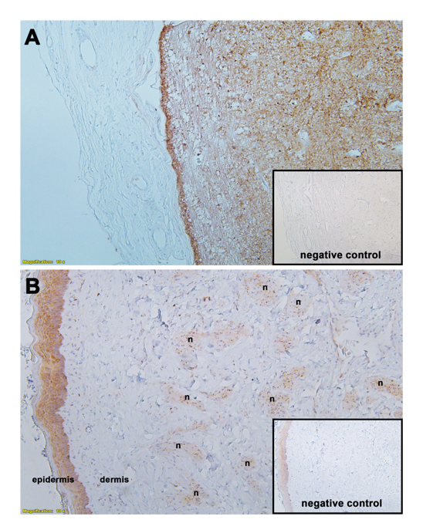
Figure S1. Primary and secondary antibody controls for PGP9.5 in A) taipan (Oxyuranus scutellatus) brain tissue and B) sea snake (Hydrophis stokesii) cephalic skin tissue. Negative controls were performed by omitting primary antibody incubation step. Note the generalised staining of the epidermis in snake skin, likely resulting from cross-reactivity of secondary and / or tertiary antibodies during immunohistochemistry procedure; nerve bundles (n) do not show same cross-reactivity.

