i)  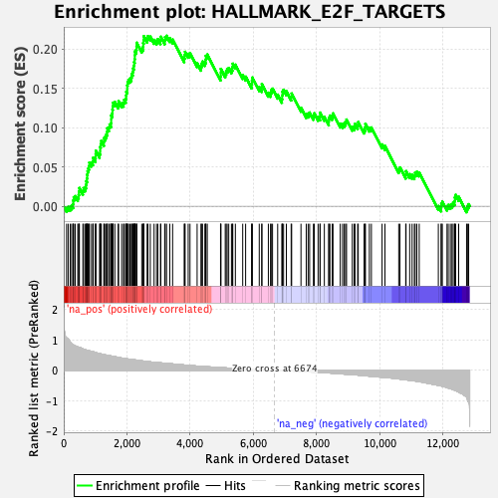 | ii)  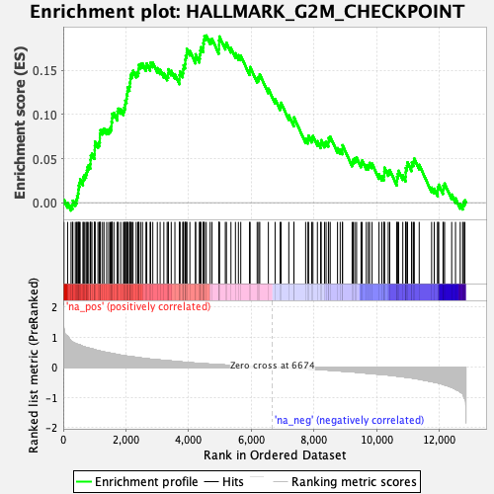
iii)  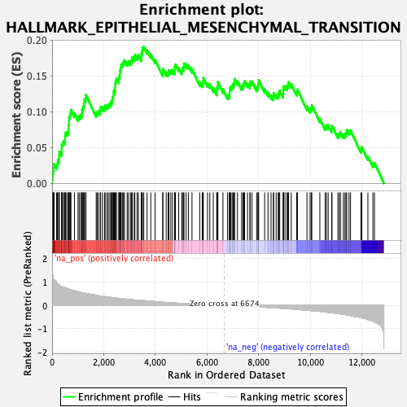 | iv)  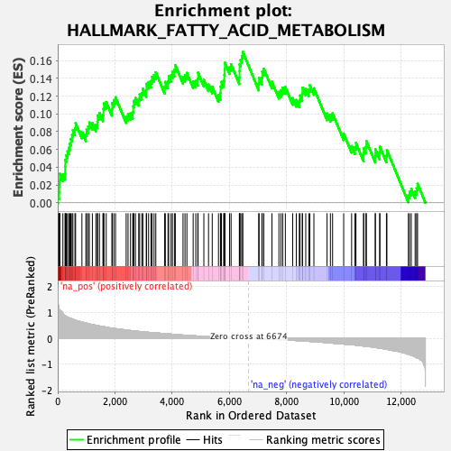
v)  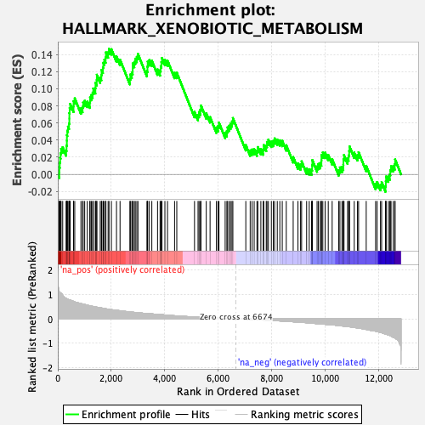 | vi)  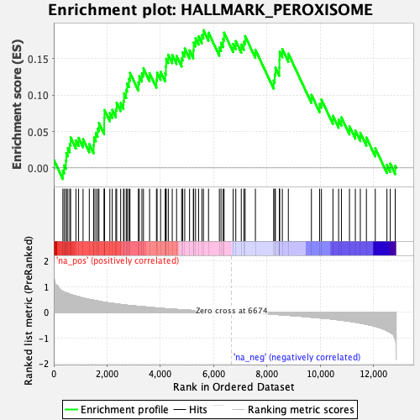
vii)  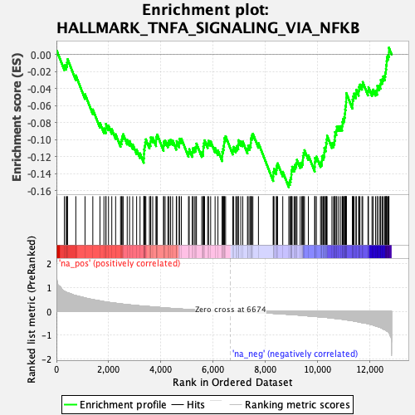 | viii)  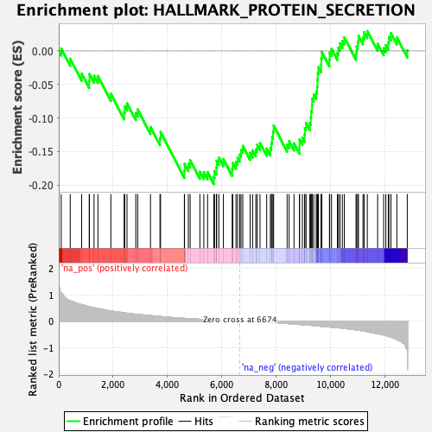
ix)
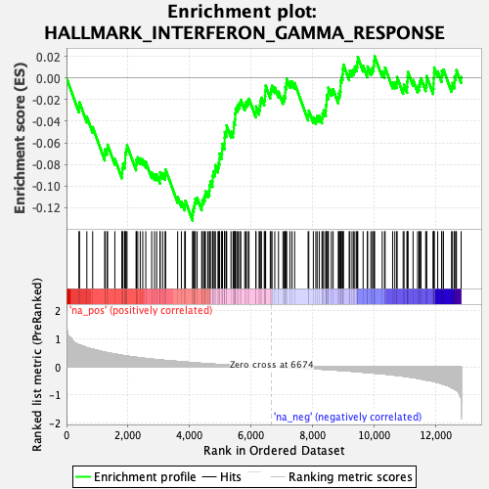

Figure S3. Gene set enrichment analyses (GSEA) of placenta genes associated with late-onset preeclampsia. Following differential expression analysis genes were ranked according to the product of the sign of the log fold change and the negative log 10 FDR (1). Hallmark pathways enriched with up-regulated genes (i-vi) and down-regulated genes (vii-ix).

- GSEA rank = (sign(logFC))*(-log₁₀(FDR))

