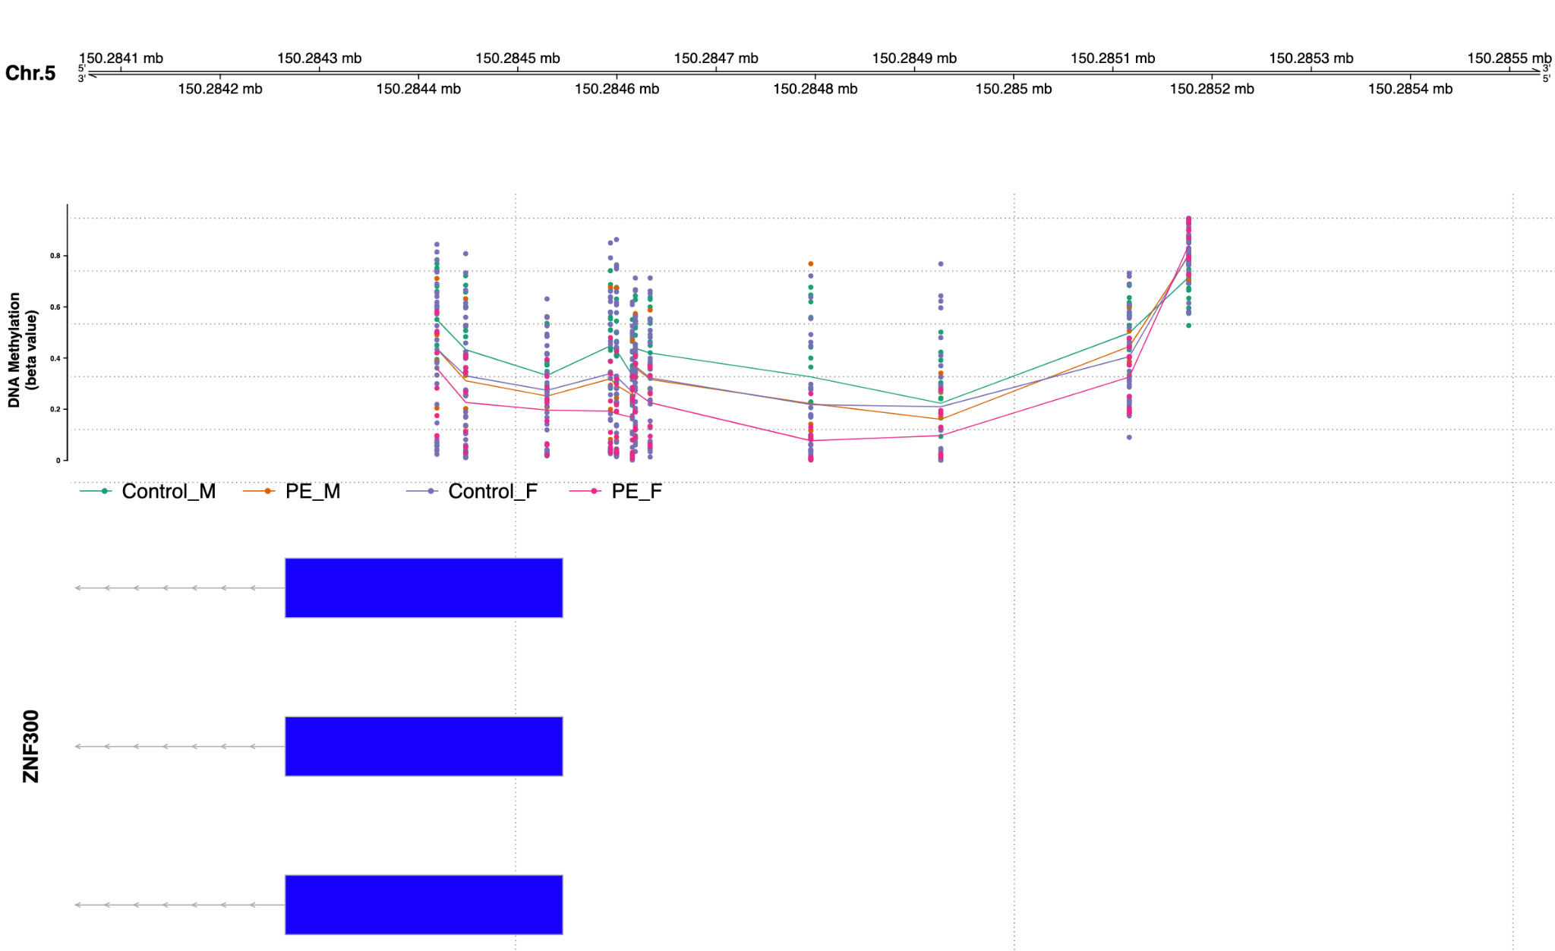

Figure S2. DNA methylation (DNAme) of the ZNF300 promoter is higher in uncomplicated than in late-onset preeclampsia in placenta from male bearing pregnancies. Interestingly the DNAme of late-onset preeclampsia placenta (male bearing) appears to be closer in beta value to that of DNAme from placenta of female bearing pregnancies.

