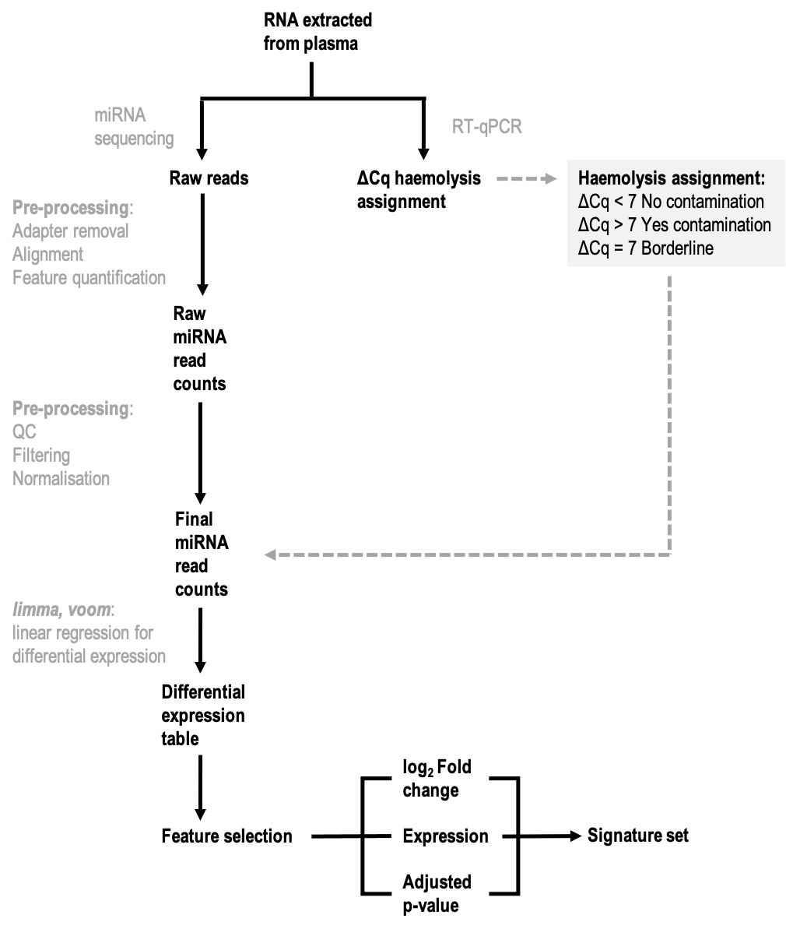
Supplementary figure 1: Haemolysis signature feature selection. Raw single-end reads from smallRNA-seq libraries are preprocessed using a range of Unix- and python-based computational tools to quantify miRNA expression in each library. Data quality is ensured through quality control steps throughout the workflow. Concurrently with sequencing, ΔCq (miR-23a-miR-451) was assessed by RT-qPCR and incorporated into the differential expression analysis.

