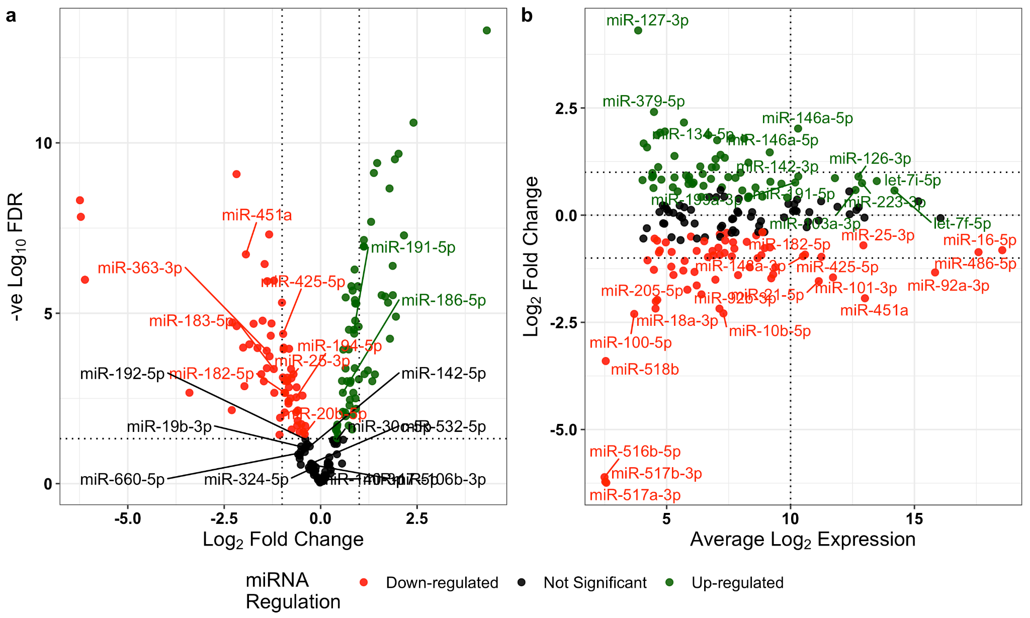
Supplementary Figure 3: (a) Volcano plot of differential expression. Linear regression 104 miRNA (FDR < 0.05) which were more highly abundant in the pregnant population compared to non-pregnant samples (red). Haemolysis Metric signature miRNAs (labelled) (b) MA plot (M (log ratio) and A (mean average)) of Log₂ fold change as a function of Log₂ average expression indicates most miRNA have an average expression < 10 Log₂ CPM. Unsurprisingly, the most differentially expressed miRNA are miR-517a-3p, miR-517b-3p, miR-516b-5p, miR-518b, all part of the highly placenta associated chromosome 19 miRNA cluster.

