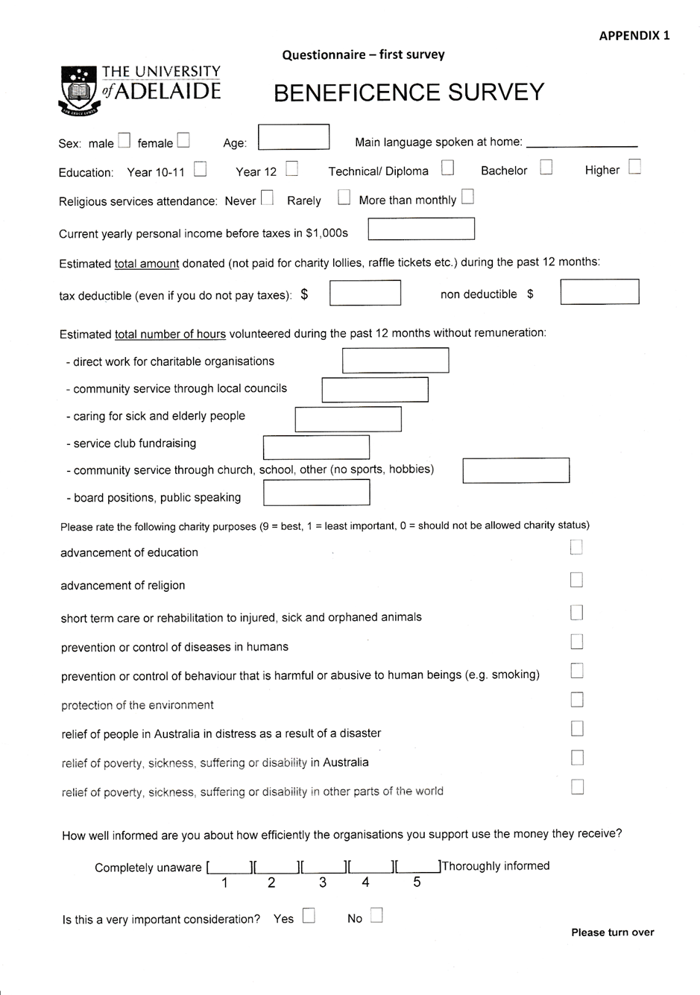

Questionnaire – second survey

Gender 1 - Male 2 - Female

1 - Age 1 - < 18 -> end of survey
2 - 18-24
3 - 25-34
4 - 35-44
5 - 45-54
6 - 55-64
7 - 65-74
8 - 75-84
9 - 85+

2 – Highest education level obtained 1 - year 11 and below
2 - Vocational training
3 - High School Certificate (yr 12)
4 - Bachelor’s degree
5 - Higher degree (e.g. master’s, PhD)

3 -Religiosity 3.1 Are you practising a religion? yes - no
3.1.1 If no: did you make this choice 1 - before the age of 21
2 - after the age of 21
3.1.2 If yes: do you practise because: 1 - it is socially expected
2 - it is really important to you

3.1.2.1 How frequently do you attend religious services, excluding special occasions like weddings and funerals?
- Never
- Less than once a year
- About once a year
- Several times a year
- About once a month
- 2 or 3 times a month
- About once a week
- Several times a week
- Every day

4 - Economic background: Do you consider yourself: 1 - poor
2 – just getting by
3 – comfortable
4 – well off
5 – wealthy

5 - Altruistic behaviour 5.1 Do you believe that:
1 – Charity is a waste of money
2 – it feels good to give a few dollars to the less fortunate
3 – people should donate about 1% of their total income to
eradicate poverty
4 – people should contribute much more, like 10% (the tithe)
to help humanity

Questionnaire – second survey (continued)

5.2 Do you actually donate: 0 - nothing
1 - less than 1% of your total
income each year
2 - more than 1% of your total
Income each year

  - Do you do voluntary work for charities:
- - No
- - Less than 1 hour a week, on average
- - 1-3 hours a week
- - More than 3 hours a week

5.4 Do you prefer to help:

1 - The animals, because they cannot help themselves
-> go to 6

2- Humans -> how do you like most to do it?

5.4.1 1 - Short term, e.g disaster relief
2 - Long term, e.g education

5.4.2 1- Hands-on, e.g. building something
2 - Campaigning for change

5.4.3 1- Providing resources (e.g. grain to eat)
2 - Helping to build resources (e.g. grain to sow)

5.4.4. 1 - Working out how to solve the problem
2 - Letting recipients decide how to solve their
problem

6 - Political tendency: Politically, do you consider yourself: 1- definitely conservative
2- moderately conservative
3- centre tending to the right
4- centre tending to the left
5- moderately progressive
6- definitely progressive

